**Project Design Phase-I**

**Solution Architecture**

|  |  |
| --- | --- |
| Date | 19 September 2022 |
| Team ID | PNT2022TMID26062 |
| Project Name | Smart Farmer-IoT enabled smart Farming Application |
| Maximum Marks | 4 Marks |

**Solution Architecture:**

The current world population of 7.3 billion people is estimated to reach 9.7 billion by 2050. Around 83 million people are added to the global population each year. This growth must be met by corresponding increases in food production.

Compared to current yields, agricultural output would have to grow by at least one third to keep up with food demand. Because farm land acreage can’t keep up with population growth, farmers have started to transition their operations to precision agriculture.

At its core, precision agriculture is deploying intelligence to fields so that farmers can gain visibility into crop yields and cost factors as they grow crops. Intelligence is collected by smart devices or IoT things equipped with sensors that continuously act on the data and transmit it to data processing locations. Today, farmers are using newly developed techniques to manage crops on micro portions of their fields to assess soil composition, control fertilizer and pesticide types, and obtain accurate yield estimates.

Precision farming would not be possible without IoT-driven solutions because they speed up farmers’ understanding of the main causes for changes in crop yields and factors that affect the measured yields and production cost drivers, including the following.

* Fertilizers and their application timing and methods.
* Irrigation and precipitation patterns.
* Air temperature and moisture levels.
* Soil composition and treatment.
* Crop care processes.
* Types of seeds used.

Measuring and collecting field, crop, and ambient data are key capabilities enabled by mature IoT solutions.

Most farms are in remote locations where data network connectivity can be spotty. Frequent weather fluctuations can cause damage to or loss of sensors and devices. These types of challenges require robust, simple, and easy to manage IoT solutions.

**Example - Solution Architecture Diagram:**

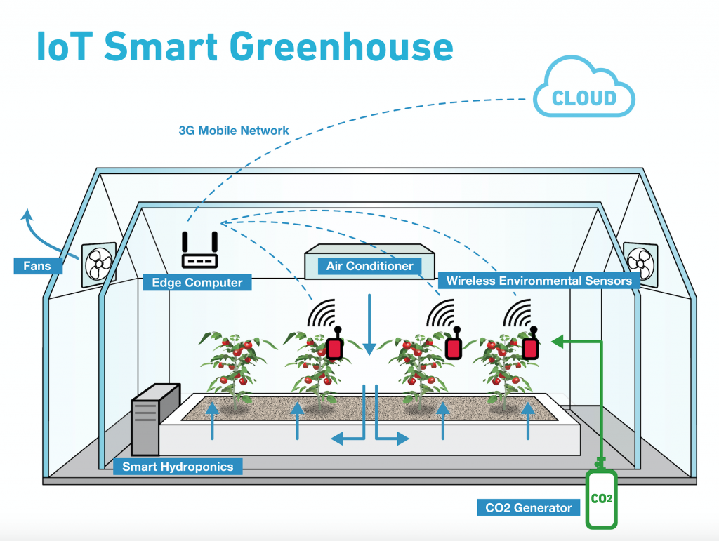

Fig1: IoT Smart Greenhouse

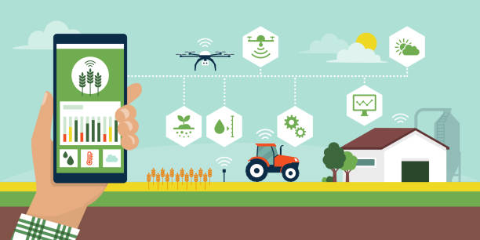

**Fig2:smart farming using IoT(mobile devices)**

Conclusion

This blog post showcased you how you can use IOT application Inference for smart agriculture and smart greenhouse use cases.

**Reference:** **https://aws.amazon.com/blogs/iot/aws-iot-driven-precision-agriculture/**